Visoka skola strukovnih studija za informacione i komunikacione tehnologije.

UsedCars

[https://bokitreks.github.io/usedcars.github.io/#](https://bokitreks.github.io/usedcars.github.io/)

Web programiranje 2

Bojan Dimitrijevic 99/18

Sadržaj 1. Uvod.......................................................................................................................................................2 Korišćeni programski jezici.............................................................................................2 Opis funkcionalnosti........................................................................................................3 2. Organizacija ...........................................................................................................................................7 Organizaciona šema.........................................................................................................7 Mapa sajta ........................................................................................................................7 Opis stranica sajta ............................................................................................................5 index.html...................................................................................................................................13 style.css..............................................................................................................................12 main.js............................................................................................................................36 Kodovi..................................................................................................................................................13 HTML............................................................................................................................13 index.html.................................................................................................................................13................................................................................................................................ JavaScript main.js.....................................................................................................................................36

JSON

Cars.json…………………………………………………………………………………………. 55

1.Uvod

Korisceni programski jezici:

1.HTML

2.CSS

3.JavaScript

4.Jquerry

5.Json

Opis funckionalnosti:

Sajt poseduje sledece funkcionalnosti:

Dinamicko ispisivanje glavnog dela sadrzaja (automobile) pomocu ajaxa, operacije sortiranja I filtriranja nad istim.

Dinamicko ispisanu navigaciju.

Detaljnu proveru kontakt forme,regExp..

Jquerry animacije slideToggle(),kao I Js slajder.

Nav bar preko Js sa offsetheight podesen da se prilikom skrolovanja lepi za gornji deo ekrana.

Kao I razni primeri DOM manipulacije. Koji se mogu bideti na samom sajtu.

Responsive design.

Burger meni takodje realizovan pomocu js-a I jquerryja.

Koriscen local storage...Objekti Js….

2.Organizacija

Single page design.

Index.html

Mapa sajta:

<?xml version="1.0" encoding="UTF-8"?>

<urlset

xmlns="http://www.sitemaps.org/schemas/sitemap/0.9">

<url>

<loc>index.html</loc>

<lastmod>2019-12-06</lastmod>

<changefreq>daily</changefreq>

<priority>1</priority>

</url>

</urlset>

Opis stranice sajta INDEX.HTML

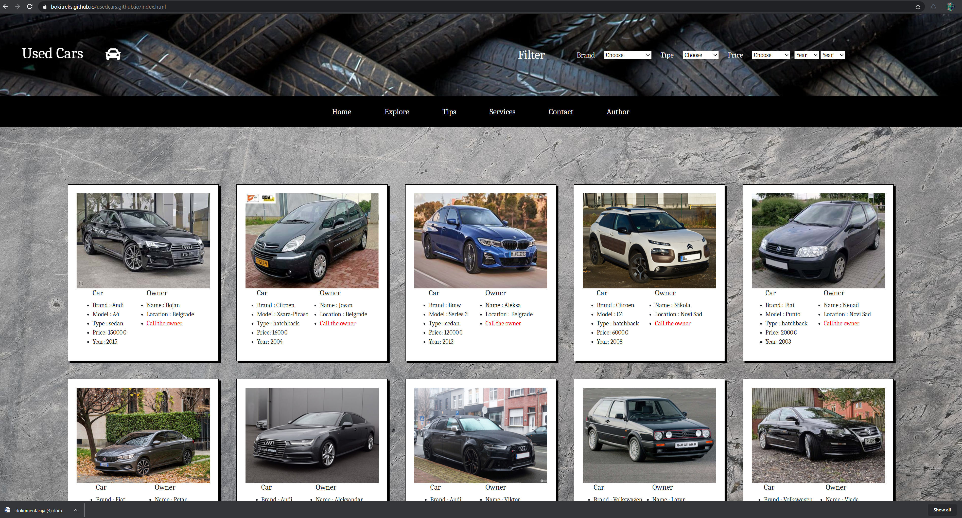

Ovaj sajt je singlepage. Funkcija ovog sajta je kupo/prodaja polovnih automobila.

Realizuje se na sledeci nacin:

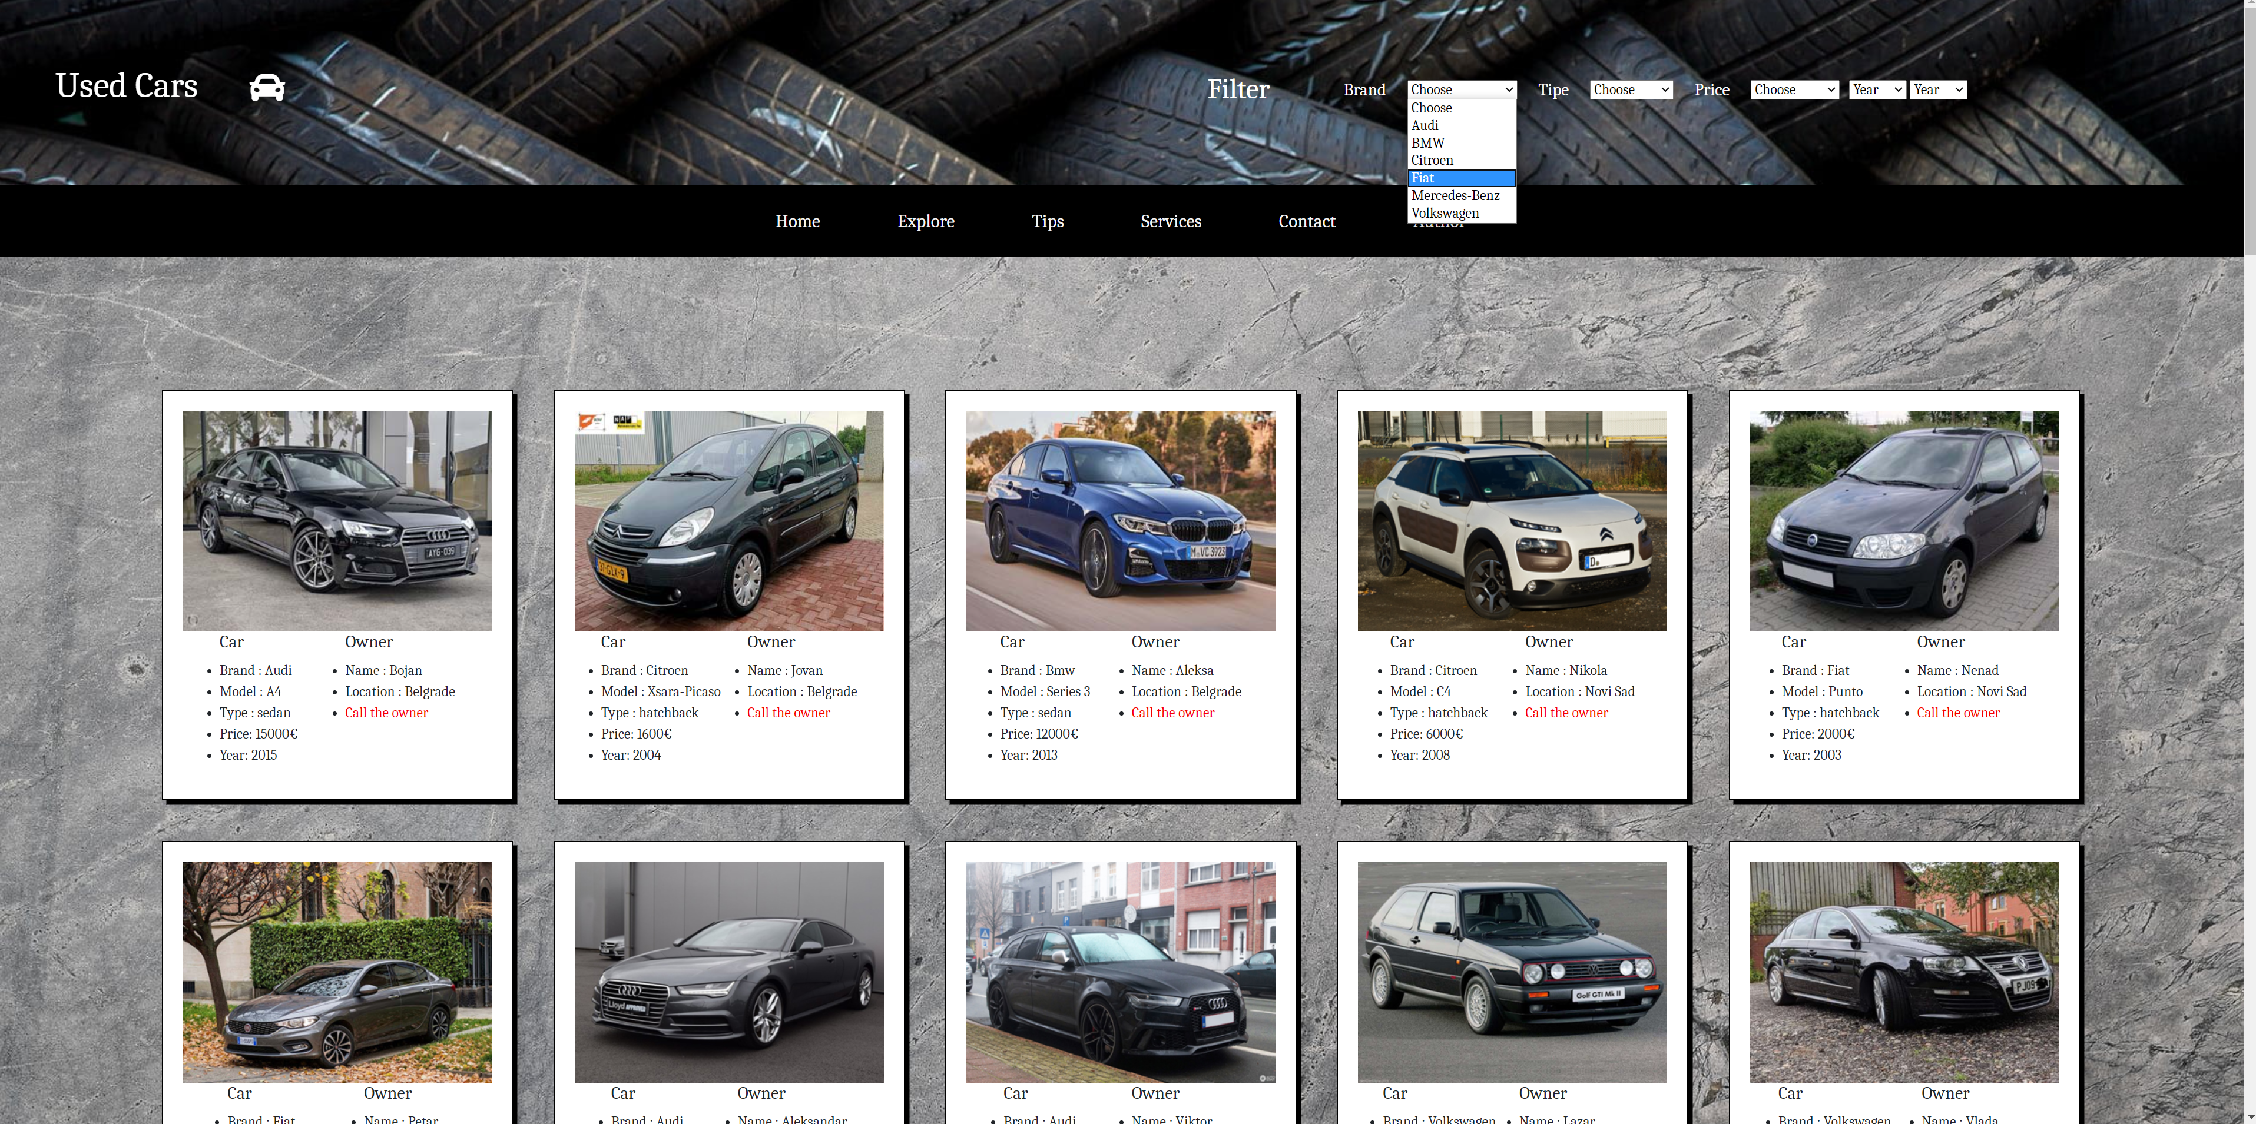

Na samom vrhu sajta imamo filter I srot opcije.Pomocu njih mozemo izabrati zeljene opcije kako bi se automobile prikazali po nasoj zrelji. Brand I Tipe su filteri a price je sort.Takodje mozemo filtrirati automobile po godini proizvodnje.

Svaki od automobila je poseban div koji je js-om dinamicki ispisan koriscenjem json fajla koji se Ajaxom dohvata u js..

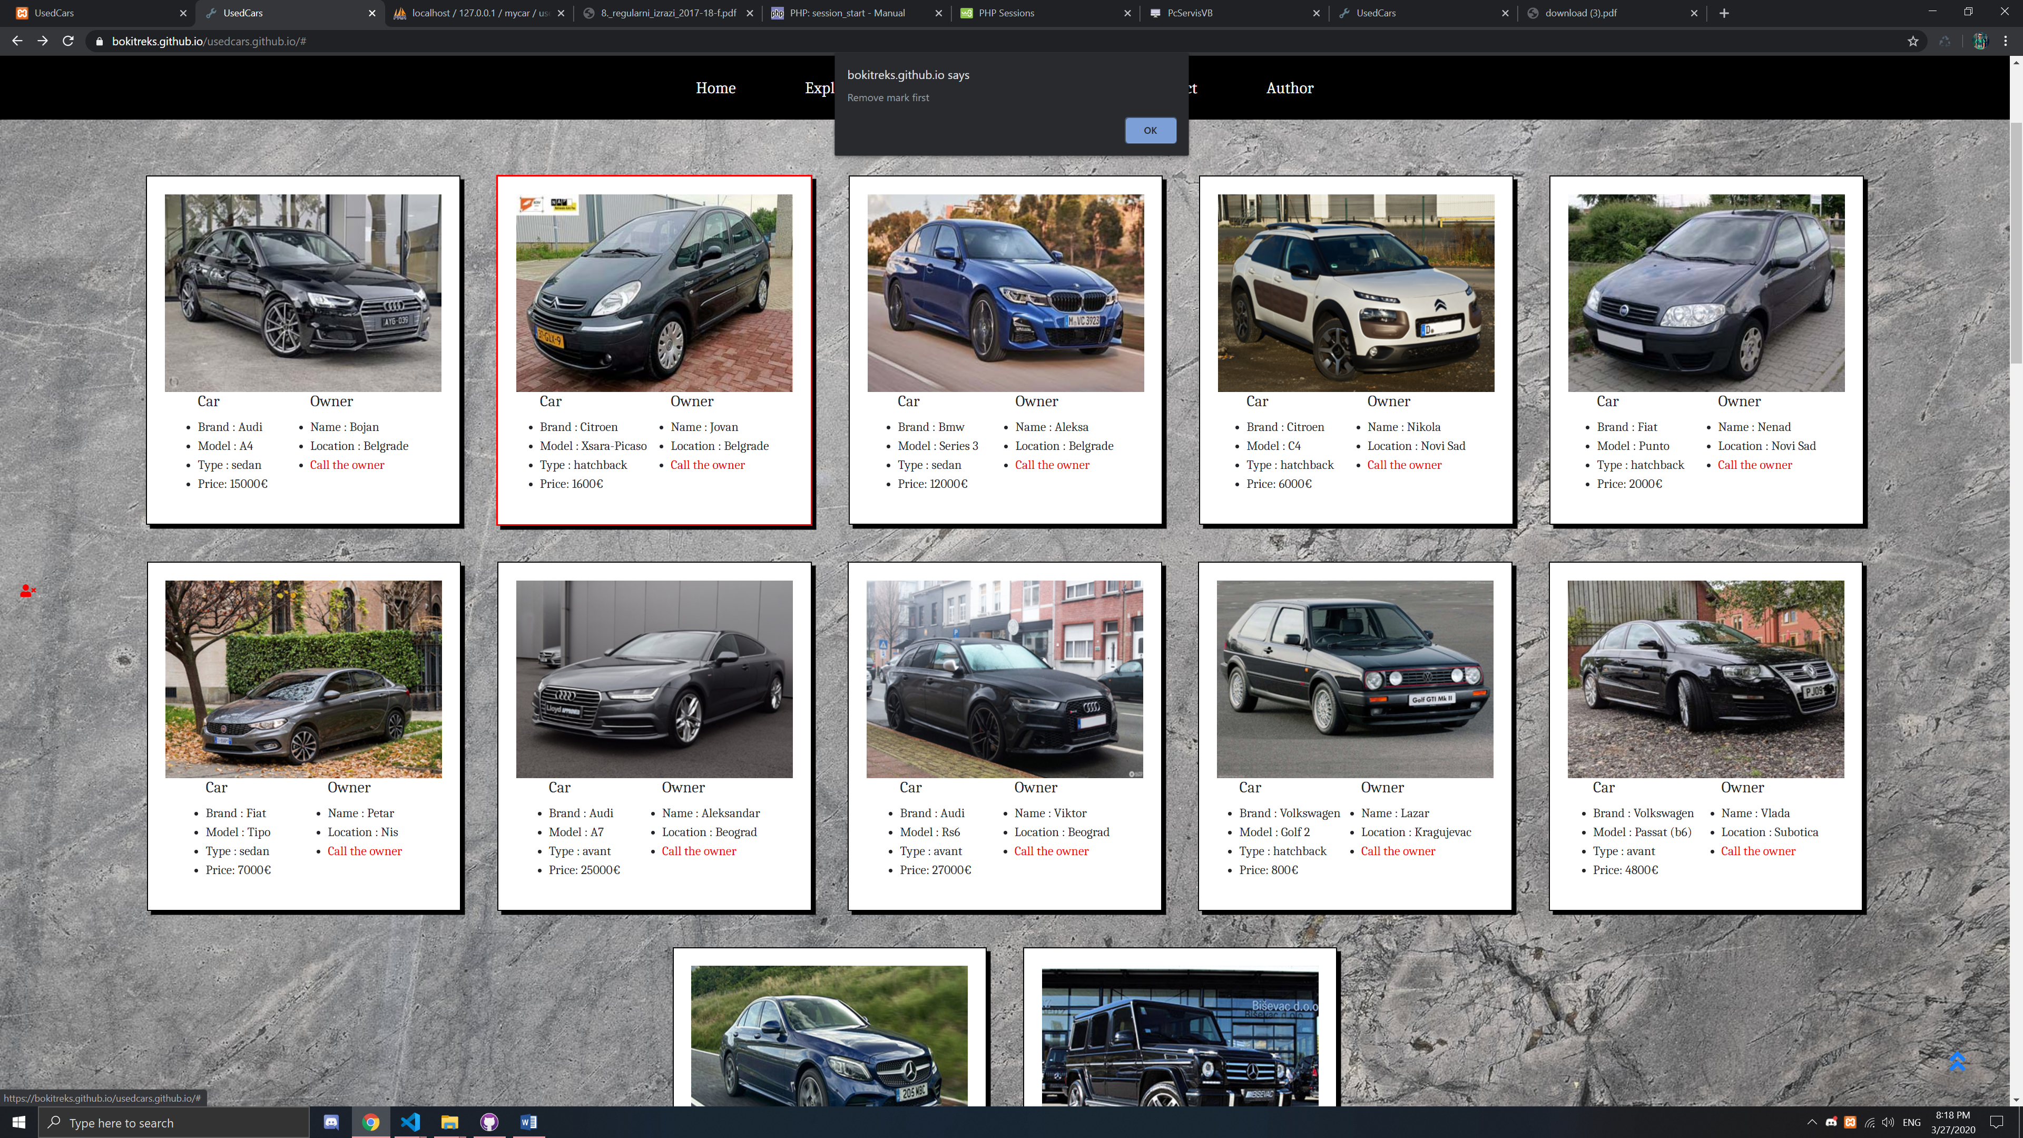

Sajt takodje nudi mogucnost oznacavanja automobila, sa pravilom da mozete oznaciti u datom momentu samo jedan automobile koji zelite da kupite..Nakon vaseg odlaska I ponovnog dolaska na sajt , koriscenjem local storage-a, vas mark ce biti zapamcen. Isti mozete sa leve strane pritiskom na crvenog ciku odnzaciti sajt I izabrati drugi automobil za kupovinu.

Sa desne strane se nalazi strelica za vracanje na vrh stranice.

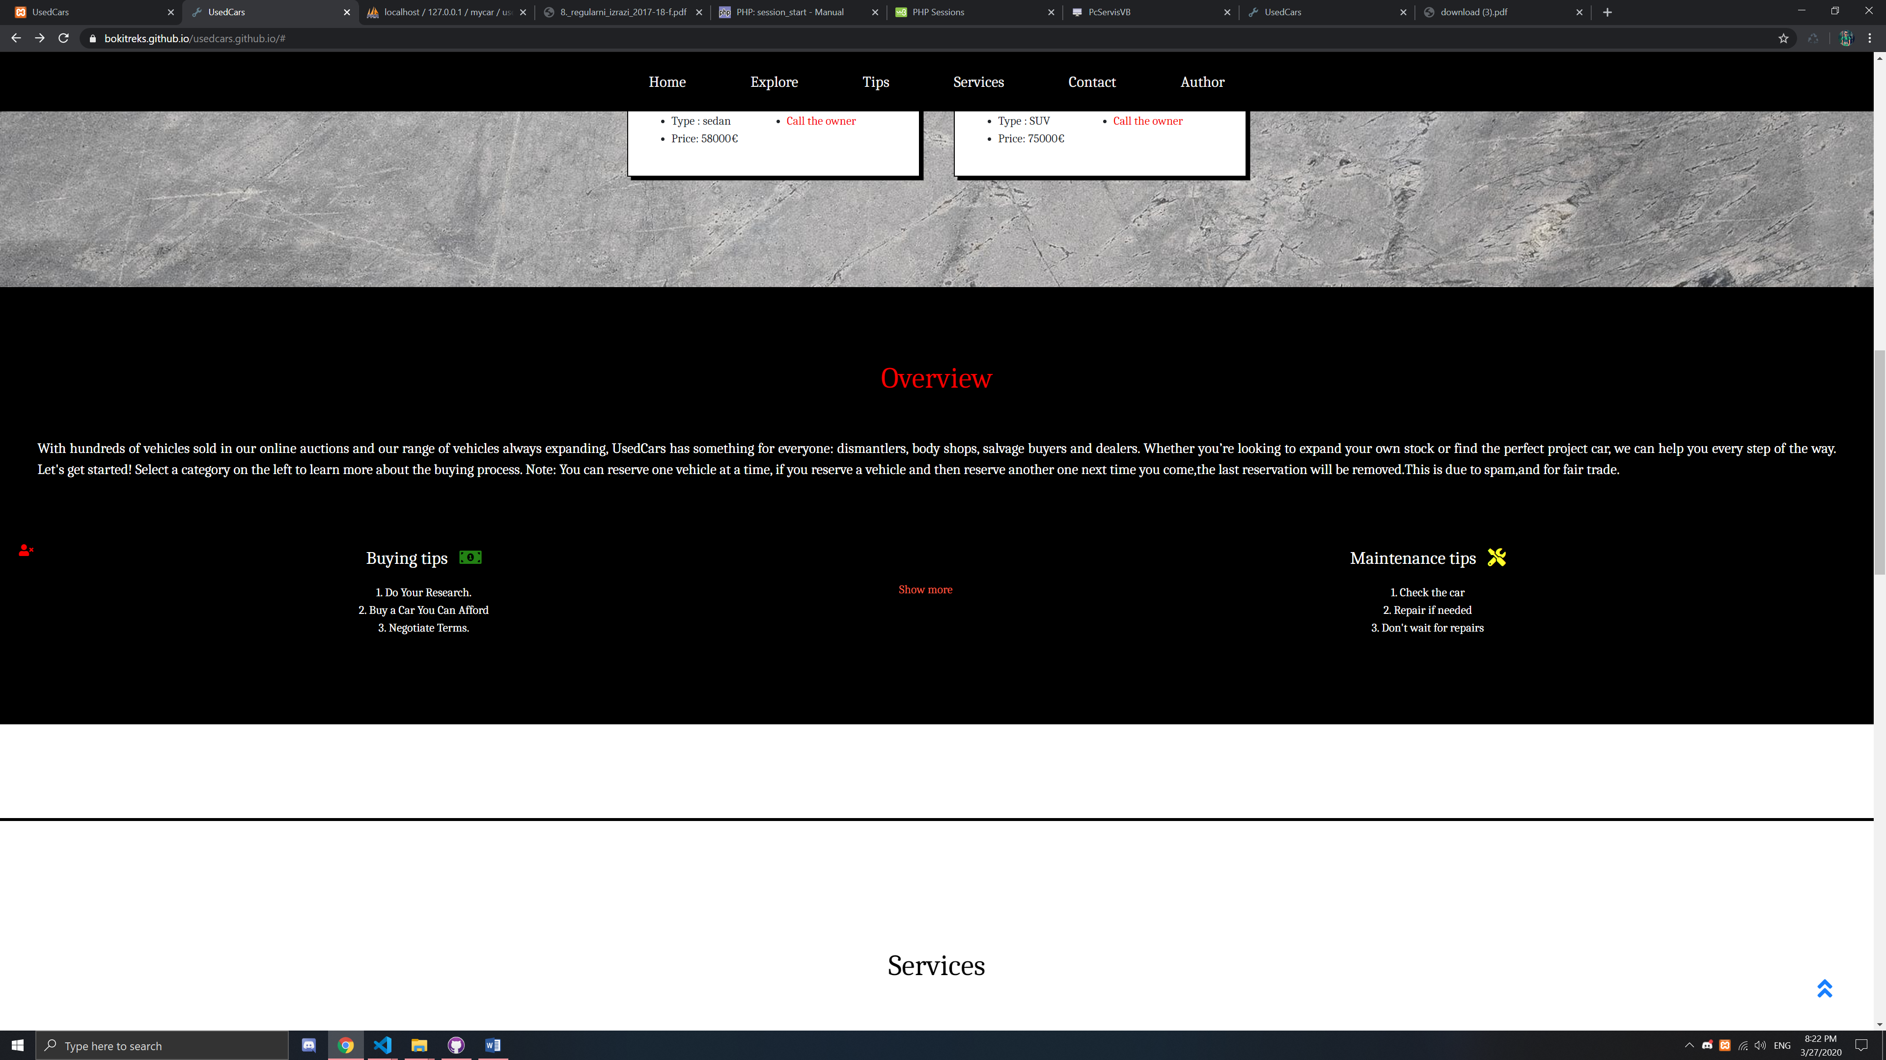

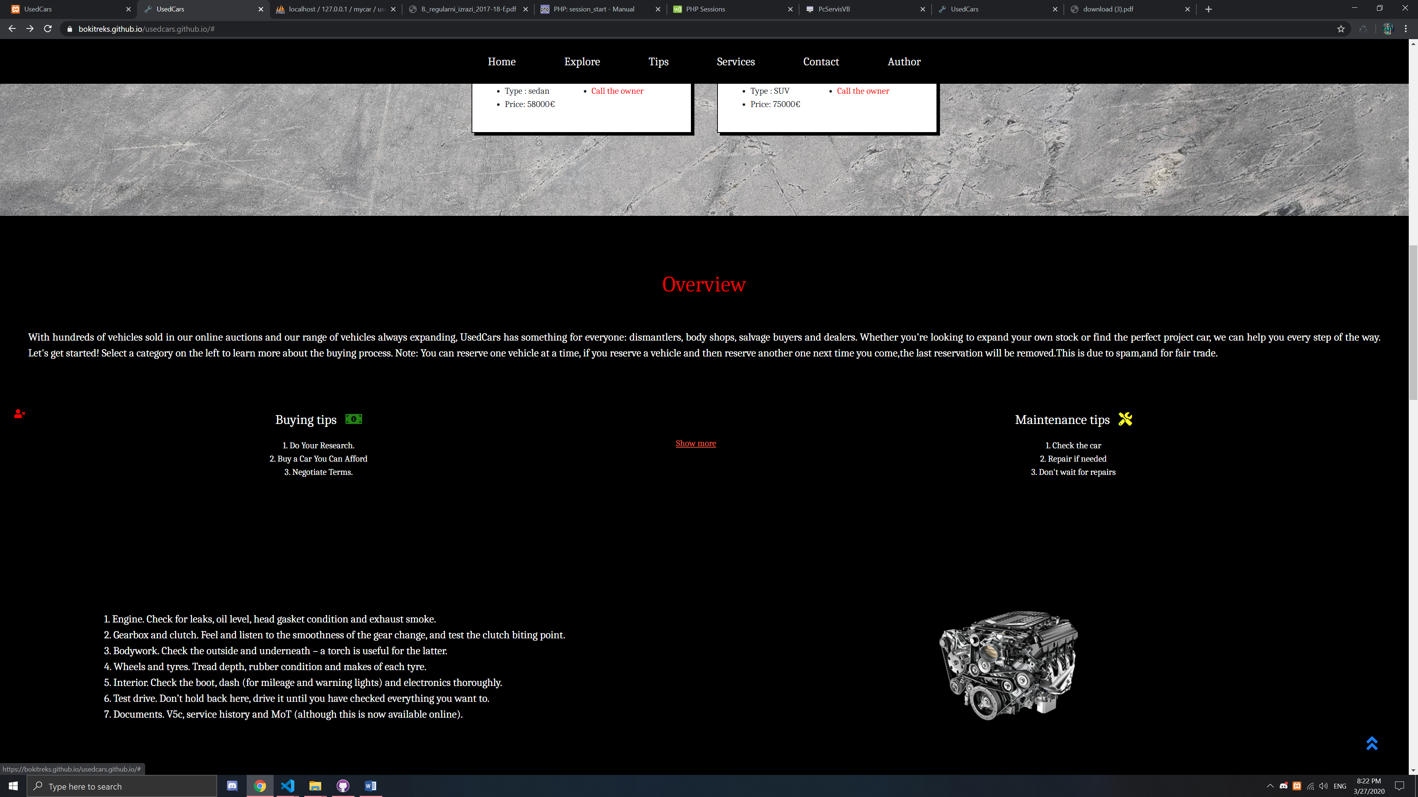

Ovde se nalazi opis sadrzaja zajedno sa skrivenim divom koji se realizovao pomocu Js-a I Jquerija.

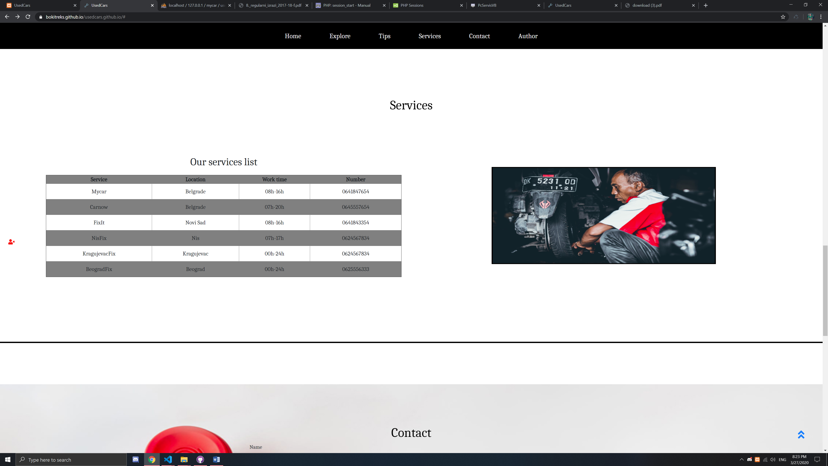

Lista servisera. Tabela za zebra efektom I slajder napravljen u Js-u.

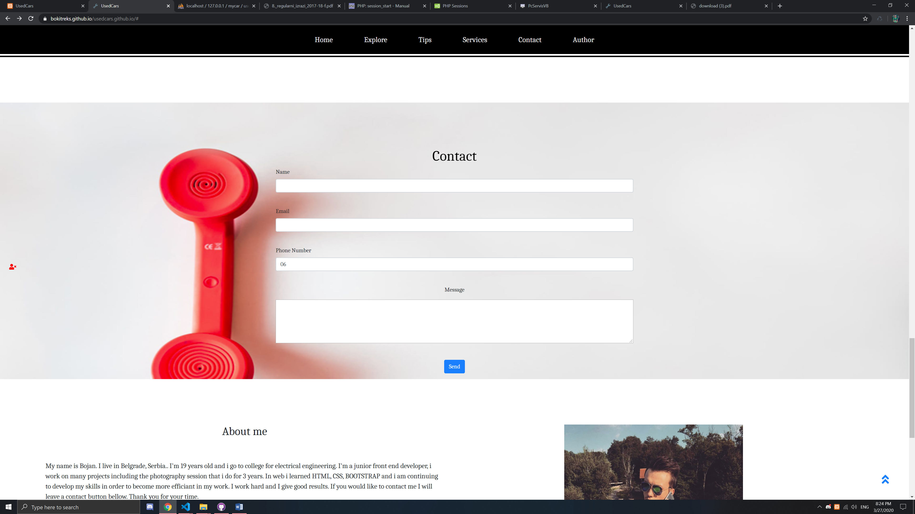

Contact forma

Sa validacijom pomocu regExp.

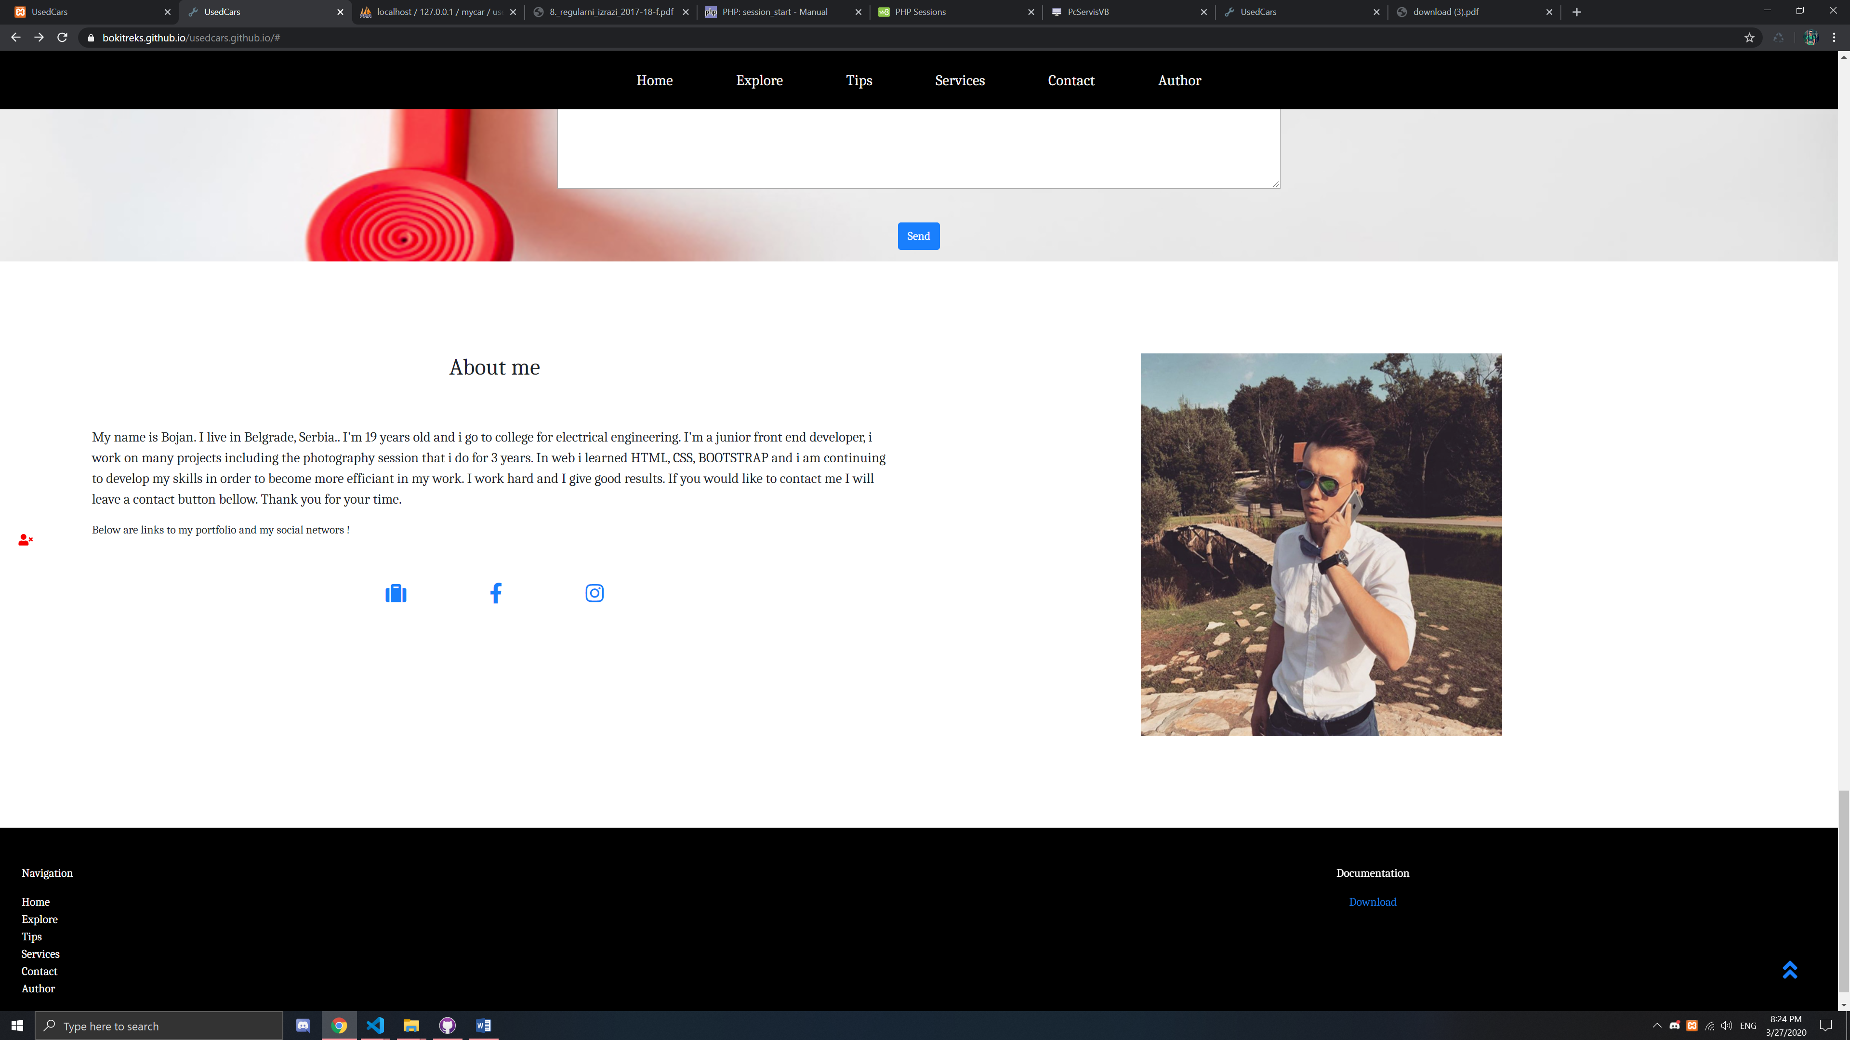

Deo stranice posvecen autoru I na kraju futer..

Kompletan kod ce biti prilozen u nastavku.

Index.html

<!doctype html>

<html lang="en">

  <head>

    <meta charset="utf-8">

    <meta name="viewport" content="width=device-width, initial-scale=1, shrink-to-fit=no">

    <script src="https://kit.fontawesome.com/47e9c3ffba.js" crossorigin="anonymous"></script>

    <meta name="keywords" content="Cars,Buy,Contact">

    <meta name="description" content="Buy a used car today!">

    <link href="https://fonts.googleapis.com/css?family=Caladea&display=swap" rel="stylesheet">

    <link rel="stylesheet" href="https://stackpath.bootstrapcdn.com/bootstrap/4.4.1/css/bootstrap.min.css" integrity="sha384-Vkoo8x4CGsO3+Hhxv8T/Q5PaXtkKtu6ug5TOeNV6gBiFeWPGFN9MuhOf23Q9Ifjh" crossorigin="anonymous">

    <link rel="stylesheet" type="text/css" href="style.css">

    <link rel="shortcut icon" href="images/ikonica.png"/>

    <title>UsedCars</title>

  </head>

  <body>

    <div id="burger">

    </div>

    <div id="strela">

 <a href="#" onclick="topFunction()"><i class="fas fa-angle-double-up"></i></a>

    </div>

    <div id="rMark">

      <a href="#" id="rem"><i class="fas fa-user-times"></i></a>

    </div>

    <div id="oBurger">

      <a id="prikazN" href="#"><i class="fas fa-bars"></i></a>

     </div>

    <nav class="container-fluid" id="vrh">

      <div class="container-fluid" id="naslov">

        <h1>Used Cars</h1>

        <a id="reset" href="index.html"><i class="fas fa-car"></i></a>

      </div>

      <div  class="container-fluid" id="filteri">

        <p id="filter">Filter</p>

        <p id="marka">Brand</p>

        <select id="marke">

          <option value="0">Choose</option>

        </select>

        <p id="cena">Tipe</p>

        <select id="karoserije">

          <option value="0">Choose</option>

        </select>

        <p id="cena">Price</p>

        <select id="cene">

          <option value="0">Choose</option>

        </select>

      </div>

    </nav>

    <div class="container-fluid" id="meni"></div>

    <div id="glavni">

    </div>

    <div id="tips" class="container-fluid">

      <h4>Overview</h4>

      <p>With hundreds of vehicles sold in our online auctions and our range of vehicles always expanding, UsedCars has something for everyone: dismantlers, body shops, salvage buyers and dealers.

        Whether you’re looking to expand your own stock or find the perfect project car, we can help you every step of the way.

        Let's get started! Select a category on the left to learn more about the buying process. Note: You can reserve one vehicle at a time, if you reserve a vehicle and then reserve another one next time you come,the last reservation will be removed.This is due to spam,and for fair trade.</p>

          <div id="tipara" class="row container-fluid">

<div id="tipss" class="container-fluid col">

 <p class="m">Buying tips &nbsp  <i id="cash" class="fas fa-money-bill-alt"></i></p>

<ul class="listat">

 <li>1. Do Your Research.</li>

 <li>2. Buy a Car You Can Afford</li>

 <li>3. Negotiate Terms. </li>

</ul>

</div>

<a href="#" id="prikazT">Show more</a>

<div id="tipsss" class="container-fluid col">

<p class="m">Maintenance tips  &nbsp  <i id="rep" class="fas fa-tools"></i></p>

<ul class="listat">

  <li>1. Check the car</li>

  <li>2. Repair if needed</li>

  <li>3. Don't wait for repairs</li>

 </ul>

</div>

          </div>

          <div id="skriveniT" class="container-fluid">

            <div class="container-fluid" id="levis">

          <p id="checkList">1. Engine. Check for leaks, oil level, head gasket condition and exhaust smoke. <br/>

            2. Gearbox and clutch. Feel and listen to the smoothness of the gear change, and test the clutch biting point.<br/>

            3. Bodywork. Check the outside and underneath – a torch is useful for the latter.<br/>

            4. Wheels and tyres. Tread depth, rubber condition and makes of each tyre.<br/>

            5. Interior. Check the boot, dash (for mileage and warning lights) and electronics thoroughly.<br/>

            6. Test drive. Don’t hold back here, drive it until you have checked everything you want to.<br/>

            7. Documents. V5c, service history and MoT (although this is now available online).</p>

          </div>

          <div class="container-fluid" id="desnis">

            <img class="img-fluid" src="images/engine.png" alt="engine"/>

            </div>

          </div>

    </div>

    <div class="container-fluid" id="services">

      <h4 id="naslovs">Services</h4>

      <div id="divs" class="container-fluid row">

          <div id="prvi" class="container-fluid col-lg-6">

          <p>Our services list</p>

          <table id="tabela" border="1px">

          <tr>

            <th>Service</th>

            <th>Location</th>

            <th>Work time</th>

            <th>Number</th>

          </tr>

          <tr>

            <td>Mycar</td>

            <td>Belgrade</td>

            <td>08h-16h</td>

            <td>0641847654</td>

          </tr>

          <tr>

            <td>Carnow</td>

            <td>Belgrade</td>

            <td>07h-20h</td>

            <td>0645557654</td>

          </tr>

          <tr>

            <td>FixIt</td>

            <td>Novi Sad</td>

            <td>08h-16h</td>

            <td>0641843354</td>

          </tr>

          <tr>

            <td>NisFix</td>

            <td>Nis</td>

            <td>07h-17h</td>

            <td>0624567834</td>

          </tr>

          <tr>

            <td>KragujevacFix</td>

            <td>Kragujevac</td>

            <td>00h-24h</td>

            <td>0624567834</td>

          </tr>

          <tr>

            <td>BeogradFix</td>

            <td>Beograd</td>

            <td>00h-24h</td>

            <td>0625556333</td>

          </tr>

          </table>

          </div>

          <div id="drugi" class="container-fluid col-lg-6">

          <div class="container-fluid" id="slajder">

          <img id="slajderr" class="img-fluid" src="images/s1.jpeg" alt="slika"/>

          </div>

          </div>

      </div>

    </div>

    <div class="container-fluid" id="contact">

      <h4 id=naslovc>Contact</h4>

      <form>

        <div class="form-row redf">

          <div class="form-group col-md-6">

            <label for="inputEmail4">Name</label>

            <input type="text" class="form-control" id="ime" name="ime"/>

          </div>

          </div>

          <br/>

          <div class="form-row redf">

            <div class="form-group col-md-6">

              <label for="inputEmail4">Email</label>

              <input type="mail" class="form-control" id="mail" name="mail"/>

            </div>

            </div>

            <br/>

          <div class="form-row redf">

            <div class="form-group col-md-6">

              <label for="inputEmail4">Phone Number</label>

              <input value="06" type="text" class="form-control" id="phone" name="phone"/>

            </div>

            </div>

            <br/>

          <div class="form-row redf" id="poslednji">

           <p>Message</p>

            <div class="form-group col-md-6">

              <textarea class="container-fluid" name="komentar" id="komentar" cols="50" rows="5"></textarea>

            </div>

            </div>

            <br/>

          <div class="form-row redf">

            <div class="form-group col-md-6" id="poslednjii">

            <input class="btn btn-primary" type="button" name="submit" id="dugme" value="Send"/>

            </div>

            </div>

          </form>

      </form>

    </div>

    <div id="about" class="container-fluid row rowGap rowFinal">

      <div class="col-lg-6 ab1">

          <h2 id="aboutn" class="after">About me</h2>

          <p class="atext">My name is Bojan. I live in Belgrade, Serbia.. I'm 19 years old and i go to college for electrical engineering. I'm a junior front end developer, i work on many projects including the photography session that i do for 3 years. In web i learned HTML, CSS, BOOTSTRAP and i am continuing to develop my skills in order to become more efficiant in my work. I work hard and I give good results. If you would like to contact me I will leave a contact button bellow. Thank you for your time.</p>

          <p>Below are links to my portfolio and my social networs !</p>

          <div class="socialAb">

              <a href="https://bokitreks.github.io/Bojan.github.io/" target="blank"><i class="fas fa-suitcase"></i></a>

              <a href="https://www.facebook.com/bojan.dimitrijevic.56" target="blank"><i class="fab fa-facebook-f"></i></a>

              <a href="https://www.instagram.com/bokila_/" target="blank"><i class="fab fa-instagram"></i></a>

          </div>

      </div>

      <div class="col-lg-6 ab2">

          <div class="jobPic">

              <img src="images/bojan.jpg" class="img-fluid asl" alt="Author picture"/>

          </div>

      </div>

  </div>

  <footer>

    <div class="container-fluid row">

<div class="col-lg-6" id="fnav">

<p>Navigation</p>

</div>

<div class="col-lg-6" id="fuse">

  <p>Documentation</p>

  <a href="dokumentacija.pdf">Download</a>

</div>

    </div>

  </footer>

    <script src="https://ajax.googleapis.com/ajax/libs/jquery/3.4.1/jquery.min.js"></script>

    <script type="text/javascript" src="main.js"></script>

    <script src="https://cdn.jsdelivr.net/npm/popper.js@1.16.0/dist/umd/popper.min.js" integrity="sha384-Q6E9RHvbIyZFJoft+2mJbHaEWldlvI9IOYy5n3zV9zzTtmI3UksdQRVvoxMfooAo" crossorigin="anonymous"></script>

    <script src="https://stackpath.bootstrapcdn.com/bootstrap/4.4.1/js/bootstrap.min.js" integrity="sha384-wfSDF2E50Y2D1uUdj0O3uMBJnjuUD4Ih7YwaYd1iqfktj0Uod8GCExl3Og8ifwB6" crossorigin="anonymous"></script>

  </body>

</html>

Style.css

* {

  margin: 0px;

  padding: 0px;

  font-family: 'Caladea', serif;

}

body #strela {

  display: none;

  position: fixed;

  top: 94%;

  left: 97%;

  font-size: 2em;

}

@media (max-width: 485px) {

  body #strela {

    top: 94%;

    left: 95%;

  }

}

body #strela a:hover {

  color: tomato;

  -webkit-transition: 1s;

  transition: 1s;

}

body nav {

  width: 100%;

  background-color: #e6e6e6;

  display: -webkit-box;

  display: -ms-flexbox;

  display: flex;

  padding: 0px;

  -webkit-box-pack: justify;

      -ms-flex-pack: justify;

          justify-content: space-between;

  background-image: url("images/wall.jpg");

  background-repeat: no-repeat;

  background-size: cover;

  background-attachment: fixed;

  color: white;

}

body nav #naslov {

  display: -webkit-box;

  display: -ms-flexbox;

  display: flex;

  padding: 2%;

  -webkit-box-align: center;

      -ms-flex-align: center;

          align-items: center;

}

body nav #naslov a {

  margin-left: 5%;

  font-size: 2.5em;

  text-decoration: none;

  color: white;

}

body nav #filteri {

  -webkit-box-align: center;

      -ms-flex-align: center;

          align-items: center;

  display: -webkit-box;

  display: -ms-flexbox;

  display: flex;

  -ms-flex-wrap: wrap;

      flex-wrap: wrap;

  padding: 1%;

  width: 100%;

}

@media (max-width: 850px) {

  body nav #filteri {

    -webkit-box-orient: vertical;

    -webkit-box-direction: normal;

        -ms-flex-direction: column;

            flex-direction: column;

  }

}

body nav #filteri #filter {

  font-size: 2em;

  margin: 5%;

  color: white;

}

@media (max-width: 1411px) {

  body nav #filteri #filter {

    font-size: 1.5em;

  }

}

@media (max-width: 850px) {

  body nav #filteri #filter {

    font-size: 2em;

  }

}

body nav #filteri p {

  font-size: 1.2em;

  margin: 2%;

  color: white;

}

@media (max-width: 1411px) {

  body nav #filteri p {

    font-size: 1em;

  }

}

body #meni {

  background-color: black;

  z-index: 999;

}

@media (max-width: 485px) {

  body #meni {

    display: none;

  }

}

body #meni #menii {

  display: -webkit-box;

  display: -ms-flexbox;

  display: flex;

  list-style: none;

  width: 60%;

  margin: 0px auto;

  -webkit-box-pack: center;

      -ms-flex-pack: center;

          justify-content: center;

  padding: 1%;

  z-index: 999;

}

body #meni #menii li {

  margin-left: 3%;

  margin-right: 3%;

}

body #meni #menii li a {

  font-size: 1.3em;

  text-decoration: none;

  color: whitesmoke;

}

body #glavni {

  width: 100%;

  display: -webkit-box;

  display: -ms-flexbox;

  display: flex;

  -ms-flex-wrap: wrap;

      flex-wrap: wrap;

  padding: 5%;

  -webkit-box-align: center;

      -ms-flex-align: center;

          align-items: center;

  -webkit-box-pack: center;

      -ms-flex-pack: center;

          justify-content: center;

  background-image: url("images/wall.jpeg");

  background-repeat: no-repeat;

  background-size: cover;

  background-attachment: fixed;

}

body #glavni .automobil {

  width: auto;

  padding: 1%;

  border: 1px solid black;

  background-color: white;

  margin: 1%;

  -webkit-box-align: center;

      -ms-flex-align: center;

          align-items: center;

  -webkit-box-pack: center;

      -ms-flex-pack: center;

          justify-content: center;

  display: -webkit-box;

  display: -ms-flexbox;

  display: flex;

  -webkit-box-orient: vertical;

  -webkit-box-direction: normal;

      -ms-flex-direction: column;

          flex-direction: column;

  -webkit-box-shadow: 5px 5px black;

          box-shadow: 5px 5px black;

}

body #glavni .automobil .opisAutomobila {

  display: -webkit-box;

  display: -ms-flexbox;

  display: flex;

  -ms-flex-pack: distribute;

      justify-content: space-around;

}

body #glavni .automobil .opisAutomobila .brTel {

  text-decoration: none;

  color: red;

}

body #tips {

  width: 100%;

  background-color: black;

  text-align: justify;

  padding: 2%;

}

@media (max-width: 850px) {

  body #tips #tipara {

    display: -webkit-box;

    display: -ms-flexbox;

    display: flex;

    -webkit-box-orient: vertical;

    -webkit-box-direction: normal;

        -ms-flex-direction: column;

            flex-direction: column;

  }

}

body #tips h4 {

  color: white;

  text-align: center;

  padding: 2%;

  font-size: 2.5em;

  color: red;

}

body #tips p {

  color: white;

  font-size: 1.2em;

}

@media (max-width: 485px) {

  body #tips p {

    font-size: 1.1em;

  }

}

body #tips p #cash {

  color: green;

}

body #tips p #rep {

  color: yellow;

}

body #tips #tipss {

  text-align: center;

  padding-top: 3%;

}

body #tips #tipss .m {

  font-size: 1.5em;

}

body #tips #tipss .listat {

  color: white;

  list-style: none;

}

body #tips #tipsss {

  text-align: center;

  padding-top: 3%;

}

body #tips #tipsss .m {

  font-size: 1.5em;

}

body #tips #tipsss .listat {

  color: white;

  list-style: none;

}

body #tips #prikazT {

  padding: 5%;

  color: tomato;

  text-align: center;

}

body #tips #skriveniT {

  display: -webkit-box;

  display: -ms-flexbox;

  display: flex;

  padding: 5%;

  margin-top: 2%;

}

@media (max-width: 850px) {

  body #tips #skriveniT {

    display: -webkit-box;

    display: -ms-flexbox;

    display: flex;

    -webkit-box-orient: vertical;

    -webkit-box-direction: normal;

        -ms-flex-direction: column;

            flex-direction: column;

  }

}

body #tips #skriveniT #desnis {

  display: -webkit-box;

  display: -ms-flexbox;

  display: flex;

  -webkit-box-pack: center;

      -ms-flex-pack: center;

          justify-content: center;

}

body #services {

  margin-top: 5%;

  border-top: 4px solid black;

  border-bottom: 4px solid black;

  padding: 5%;

}

body #services #naslovs {

  color: white;

  text-align: center;

  padding: 2%;

  font-size: 2.5em;

  color: black;

}

body #services #divs {

  display: -webkit-box;

  display: -ms-flexbox;

  display: flex;

  -ms-flex-pack: distribute;

      justify-content: space-around;

  -webkit-box-align: center;

      -ms-flex-align: center;

          align-items: center;

}

body #services #divs #prvi {

  display: -webkit-box;

  display: -ms-flexbox;

  display: flex;

  -webkit-box-orient: vertical;

  -webkit-box-direction: normal;

      -ms-flex-direction: column;

          flex-direction: column;

  -webkit-box-align: center;

      -ms-flex-align: center;

          align-items: center;

}

body #services #divs #prvi p {

  text-align: center;

  font-size: 2em;

}

body #services #divs #prvi #tabela {

  -webkit-box-pack: center;

      -ms-flex-pack: center;

          justify-content: center;

  -webkit-box-align: center;

      -ms-flex-align: center;

          align-items: center;

  text-align: center;

  font-size: 1.1em;

  width: 100%;

}

@media (max-width: 850px) {

  body #services #divs #prvi #tabela {

    width: auto;

  }

}

body #services #divs #prvi #tabela tr td {

  padding: 1%;

}

body #services #divs #drugi {

  display: -webkit-box;

  display: -ms-flexbox;

  display: flex;

  -webkit-box-align: center;

      -ms-flex-align: center;

          align-items: center;

  padding: 5%;

}

body #services #divs #drugi #slajder {

  width: 80%;

  margin-left: 15%;

}

@media (max-width: 485px) {

  body #services #divs #drugi #slajder {

    width: 100%;

  }

}

body #services #divs #drugi #slajder #slajderr {

  border: 3px solid black;

}

body #contact {

  background-image: url("images/contact.jpg");

  background-repeat: no-repeat;

  background-size: cover;

  margin-top: 5%;

}

body #contact #naslovc {

  color: white;

  text-align: center;

  padding-top: 5%;

  font-size: 2.5em;

  color: black;

}

body form {

  margin: 0px auto;

  width: 80%;

}

body form .redf {

  -webkit-box-pack: center;

      -ms-flex-pack: center;

          justify-content: center;

}

body form #poslednji {

  display: -webkit-box;

  display: -ms-flexbox;

  display: flex;

  -webkit-box-orient: vertical;

  -webkit-box-direction: normal;

      -ms-flex-direction: column;

          flex-direction: column;

  -webkit-box-align: center;

      -ms-flex-align: center;

          align-items: center;

  -webkit-box-pack: center;

      -ms-flex-pack: center;

          justify-content: center;

}

body form #poslednjii {

  display: -webkit-box;

  display: -ms-flexbox;

  display: flex;

  -webkit-box-pack: center;

      -ms-flex-pack: center;

          justify-content: center;

  -webkit-box-align: center;

      -ms-flex-align: center;

          align-items: center;

}

body #about {

  padding: 5%;

}

body #about .jobPic {

  display: -webkit-box;

  display: -ms-flexbox;

  display: flex;

  -webkit-box-pack: center;

      -ms-flex-pack: center;

          justify-content: center;

}

body #about #aboutn {

  text-align: center;

}

body #about .atext {

  font-size: 1.2em;

  padding-top: 5%;

}

body #about .socialAb {

  text-align: center;

  margin-top: 5%;

}

body #about .socialAb a {

  padding: 5%;

  font-size: 1.8em;

}

body footer {

  width: 100%;

  background-color: black;

  display: -webkit-box;

  display: -ms-flexbox;

  display: flex;

  -webkit-box-pack: center;

      -ms-flex-pack: center;

          justify-content: center;

}

body footer div {

  color: white;

  padding: 1%;

}

body footer #fnav {

  display: -webkit-box;

  display: -ms-flexbox;

  display: flex;

  -webkit-box-orient: vertical;

  -webkit-box-direction: normal;

      -ms-flex-direction: column;

          flex-direction: column;

}

@media (max-width: 1233px) {

  body footer #fnav {

    -webkit-box-align: center;

        -ms-flex-align: center;

            align-items: center;

  }

}

body footer #fnav ul {

  list-style: none;

}

body footer #fnav ul li a {

  color: white;

  text-decoration: none;

}

body footer #fuse {

  text-align: center;

}

body #oBurger {

  width: 100%;

  padding: 2%;

  display: none;

  position: fixed;

  z-index: 999;

}

@media (max-width: 485px) {

  body #oBurger {

    display: block;

  }

}

.fixed-nav {

  position: fixed;

  top: 0;

  background-color: white;

}

.aktivan {

  color: red;

}

.greska {

  border: 2px solid red;

}

#rMark {

  position: fixed;

  display: none;

  top: 50%;

  left: 1%;

  z-index: 997;

}

#rMark a {

  text-decoration: none;

  color: red;

}

#burger {

  display: none;

  position: fixed;

  width: 40%;

  height: 100%;

  background-color: black;

  text-align: center;

  z-index: 998;

}

#burger ul {

  margin-top: 20%;

}

#burger ul li {

  padding: 5%;

}

#burger ul li a {

  color: white;

}

/*# sourceMappingURL=style.css.map */

MAIN.JS

$(document).ready(function(){

    $('#prikazN').on('click',function(e){

        e.preventDefault();

        $('#burger').slideToggle();

    });

    if(localStorage.getItem("favs")!=0){

        document.getElementById("rMark").style.display="block";

    }

    document.getElementById("rMark").addEventListener('click',function(e){

    if(localStorage.getItem("favs")==0){

        document.getElementById("rMark").style.display="none";

    }

else{

    document.getElementById("rMark").style.display="block";

        e.preventDefault();

        localStorage.setItem("favs",0);

        alert("Mark removed");

        var boja=document.getElementsByClassName('automobil');

                    for(b=0;b<boja.length;b++){

                        boja[b].style.border="1px solid black";

                    }

                    document.getElementById("rMark").style.display="none";

}

});

    if(localStorage){

      document.getElementById("marke").value=localStorage.getItem("brand");

      var x = document.getElementById("marke").value;

      if(x!=0){

          filterMeSortMe();

      }else{}

       document.getElementById("karoserije").value=localStorage.getItem("tipe");

       var y=document.getElementById("karoserije").value;

       if(y!=0){

        filterMeSortMe();

    }else{}

       document.getElementById("cene").value=localStorage.getItem("price");

       var z = document.getElementById("cene").value;

       if(z!=0){

        filterMeSortMe();

    }

    }

    else{

        alert("Vas browser ne podrzava localstorage!");

    }

    document.getElementById("reset").addEventListener('click',function(){

        localStorage.setItem("brand",0);

        localStorage.setItem("tipe",0);

        localStorage.setItem("price",0);

    });

document.getElementById("marke").addEventListener('change',filterMeSortMe);

document.getElementById("karoserije").addEventListener('change',filterMeSortMe);

document.getElementById("cene").addEventListener('change',filterMeSortMe);

document.getElementById("dugme").addEventListener('click',function(){

 var ime=document.getElementById("ime").value;

 var mail=document.getElementById("mail").value;

 var broj=document.getElementById("phone").value;

 var komentar=document.getElementById("komentar").value;

 var regExpIme=/^[A-Z][a-z]{2,12}$/

 var regExpMail=/^[\w\.\-]{2,15}@[a-z \.]{2,10}\.[a-z]{2,5}$/

 var regExpNumber=/^(06)[0-9][0-9]{6,8}$/

 var regExpKomentar=/^[\w\.\,\-\s]{3,40}$/

if(regExpIme.test(ime)){

    console.log("Ime je ok");

    document.getElementById("ime").classList.remove("greska");

}else{

    document.getElementById("ime").classList.add("greska");

}

if(regExpMail.test(mail)){

    console.log("Mail je ok");

    document.getElementById("mail").classList.remove("greska");

}else{

    document.getElementById("mail").classList.add("greska");

}

if(regExpNumber.test(broj)){

    console.log("Broj je ok");

    document.getElementById("phone").classList.remove("greska");

}else{

    document.getElementById("phone").classList.add("greska");

}

if(komentar==""){

    document.getElementById("komentar").classList.add("greska");

}else{

    if(regExpKomentar.test(komentar)){

        document.getElementById("komentar").classList.remove("greska");

    }else{

        console.log("Greska komentar");

    }

}

});

$('table tr:even').css({

'background-color':'gray',

});

var nizSlika=["images/s1.jpeg","images/s2.jpeg","images/s3.jpg"];

var brojac=1;

setInterval(function(){

if(brojac==nizSlika.length){

    brojac=0;

    $('#slajderr').attr('src',nizSlika[brojac]);

    brojac++;

}else{

$('#slajderr').attr('src',nizSlika[brojac]);

brojac++;

}

},3500);

});

dohvatiAutomobile();

strela = document.getElementById("strela");

window.onscroll = function() {scrollFunction()};

function scrollFunction() {

  if (document.body.scrollTop > 20 || document.documentElement.scrollTop > 20) {

    strela.style.display = "block";

  } else {

    strela.style.display = "none";

  }

}

function topFunction() {

  document.body.scrollTop = 0;

  document.documentElement.scrollTop = 0;

}

var nizMeni=[["Home","#vrh"],["Explore","#glavni"],["Tips","#tips"],["Services","#services"],["Contact","#contact"],["Author","#about"]]

var meni="<ul id='menii'>";

var nizBrand=[["Audi",1],["BMW",2],["Citroen",3],["Fiat",4],["Mercedes-Benz",5],["Volkswagen",6]];

var brendovi="";

var nizTipovi=[["Avant",1],["Sedan",2],["Hatchback",3],["SUV",4]];

var tipovi="";

var nizCene=[["Low to high",1],["High to low",2]];

var cene="";

for(var i=0;i<nizBrand.length;i++){

brendovi+="<option value='"+nizBrand[i][1]+"'>"+nizBrand[i][0]+"</option>";

}

console.log(brendovi);

document.getElementById("marke").innerHTML+=brendovi;

for(var i=0;i<nizTipovi.length;i++){

    tipovi+="<option value='"+nizTipovi[i][1]+"'>"+nizTipovi[i][0]+"</option>";

}

document.getElementById("karoserije").innerHTML+=tipovi;

for(var i=0;i<nizCene.length;i++){

    cene+="<option value='"+nizCene[i][1]+"'>"+nizCene[i][0]+"</option>";

}

document.getElementById("cene").innerHTML+=cene;

for(var i=0;i<nizMeni.length;i++){

meni+="<li><a class='link' href='"+nizMeni[i][1]+"' class='linkm'>" + nizMeni[i][0] + "</a></li>";

}

meni+="</ul>";

document.getElementById("meni").innerHTML=meni;

var godSel1=document.getElementById("godiste1");

var godSel2=document.getElementById("godiste2");

for(var i=1970;i<=2020;i++){

    godSel1.innerHTML+="<option value='"+i+"'>" + ">" + i + "</option>";

    godSel2.innerHTML+="<option value='"+i+"'>" + "<" + i + "</option>";

}

document.getElementById("godiste1").addEventListener('change',filterMeSortMe);

document.getElementById("godiste2").addEventListener('change',filterMeSortMe);

function ispisiAutomobile(data){

    var ispis="";

    for(auto of data){

       ispis+=`<div class="container-fluid automobil">

    <a href="#" class='fav' id="${auto.id}" > <img class="img-fluid" src="${auto.image.src}" alt="${auto.image.alt}"> </a>

       <div class="container-fluid opisAutomobila">

       <ul class="specs "container-fluid"">

       <h5>Car</h5>

       <li class="opisAuta">Brand : ${auto.brand}</li>

       <li class="opisAuta">Model : ${auto.specs.model}</li>

       <li class="opisAuta">Type : ${auto.type}</li>

       <li class="opisAuta">Price: ${auto.price}&euro;</li>

       <li class="opisAuta">Year: ${auto.year}</li>

     </ul>

     <ul class="owner "container-fluid"">

        <h5>Owner</h5>

       <li class="opisVlasnika">Name : ${auto.owner.name}</li>

       <li class="opisVlasnika">Location : ${auto.owner.location}</li>

       <li><a href="#" class="brTel">Call the owner</a> </li>

       <li class="number sakrij"> ${auto.owner.number} </li>

     </ul>

   </div>

      </div>`

    }

    document.getElementById("glavni").innerHTML=ispis;

    var nizFavv=[];

    nizFav=document.getElementsByClassName('fav');

            for(n=0;n<nizFav.length;n++){

                nizFav[n].addEventListener('click',function(e){

                    e.preventDefault();

                    console.log(this.id);

                    if(localStorage.getItem("mark")==0){

                    }else{

                    localStorage.setItem("mark",this.id);

                    if(localStorage.getItem("favs")==0){

                        alert("Marked for purchase");

                        localStorage.setItem("favs",nizFavv);

                        var boja=document.getElementsByClassName('automobil');

                        for(b=0;b<boja.length;b++){

                            boja[b].style.border="1px solid black";

                        }

                        this.parentElement.style.border="2px solid red";

                        nizFavv.push(this.id);

                        localStorage.setItem("favs",nizFavv);

                        console.log(localStorage.getItem("favs"));

                        document.getElementById("rMark").style.display="block";

                    }else{

                        alert("Remove mark first");

                    }

                }

                })

            }

            var favCars=localStorage.getItem("favs");

            var favCarsId=[];

            if(favCars!=null){

            for(var f=0;f<favCars.length;f++){

        if(f%2==0){

            favCarsId.push(favCars[f]);

            console.log(favCarsId);

        }else{

            console.log("zarez");

        }

    }       }

    else{

        localStorage.setItem("favs",0);

    }

    var f=document.getElementsByClassName("fav");

          for(var i=0;i<f.length;f++){

            for(var c=0;c<favCarsId.length;c++){

                if(f[i]==favCarsId[c]){

                    console.log("nista");

                }

                else{

                    console.log(favCarsId[c]);

                    cc=document.getElementsByClassName("fav");

                    for(var s=0;s<cc.length;s++){

                    if(cc[s].id==favCarsId[c]){

                        cc[s].parentElement.style.border="2px solid red";

                    }

                }

                  }

            }

          }

          $('#skriveniT').hide();

          $('#prikazT').on('click',function(e){

             e.preventDefault();

             $('#skriveniT').slideToggle();

          });

     $(".sakrij").hide();

     $(".brTel").on('click',function(e){

         e.preventDefault();

         $(this).parent().next().slideToggle();

     });

}

function dohvatiAutomobile() {

    $.ajax({

        url:"cars.json",

        method:"GET",

        dataType:"JSON",

        success:function(data){

            ispisiAutomobile(data);

        },

        error:function(xhr,status,error){

            console.log("Greska");

        }

    })

}

var nav=document.getElementById("meni");

var topNav=nav.offsetTop;

function fixNav() {

if(window.scrollY>=topNav){

    document.body.style.paddingTop=nav.offsetHeight+"px";

    nav.classList.add('fixed-nav');

}else{

    nav.classList.remove('fixed-nav');

    document.body.style.paddingTop=0;

}

}

window.addEventListener('scroll',fixNav);

function filterMeSortMe(){

    var brend = document.getElementById('marke').value;

    var tip = document.getElementById('karoserije').value;

    var sorted = document.getElementById('cene').value;

    var god1=document.getElementById("godiste1").value;

    var god2=document.getElementById("godiste2").value;

    localStorage.setItem("brand",brend);

    localStorage.setItem("tipe",tip);

      localStorage.setItem("price",sorted);

    var tipoviNiz = [];

    var brandNizAkoJeTipNizNula;

    var tipoviAkoNemaBrenda;

    console.log(brend, tip, sorted)

    $.ajax({

        url:"cars.json",

        method:"GET",

        dataType:"JSON",

        success:function(data){

            if(brend != 0){

                var nizBrendova = data.filter(el => {

                    if(brend == el.idb)return el;

                })

                console.log(nizBrendova);

                if(tip != 0){

                    tipoviNiz = nizBrendova.filter(el => {

                        if(tip == el.idk)return el;

                    })

                    console.log(tipoviNiz);

                }

                if(tipoviNiz.length != 0){

                    if(sorted == 1){

                        tipoviNiz.sort((a,b) => {

                            if(a.price > b.price){

                                return 1;

                            }

                            if(a.price < b.price){

                                return -1;

                            }

                            if(a.price == b.price)return 0;

                        })

                    }

                    if(sorted == 2){

                        tipoviNiz.sort((a,b) => {

                            if(a.price > b.price){

                                return -1;

                            }

                            if(a.price < b.price){

                                return 1;

                            }

                            if(a.price == b.price)return 0;

                        })

                    }

                    if(god1==0 && god2==0){

                        ispisiAutomobile(tipoviNiz);

                    }else{

                        filtrirajGodiste(tipoviNiz);

                    }

                }

                else{

                    if(tip != 0){

                        brandNizAkoJeTipNizNula = nizBrendova.filter(el => {

                            if(tip != 0 && tip == el.idk)return el;

                        })

                        console.log(brandNizAkoJeTipNizNula);

                            if(sorted == 1){

                                brandNizAkoJeTipNizNula.sort((a,b) => {

                                    if(a.price > b.price){

                                        return 1;

                                    }

                                    if(a.price < b.price){

                                        return -1;

                                    }

                                    if(a.price == b.price)return 0;

                                })

                            }

                            if(sorted == 2){

                                brandNizAkoJeTipNizNula.sort((a,b) => {

                                    if(a.price > b.price){

                                        return -1;

                                    }

                                    if(a.price < b.price){

                                        return 1;

                                    }

                                    if(a.price == b.price)return 0;

                                })

                        }

                        if(god1==0 && god2==0){

                            ispisiAutomobile(brandNizAkoJeTipNizNula);

                        }else{

                            filtrirajGodiste(brandNizAkoJeTipNizNula);

                        }

                    }

                    else{

                                    if(sorted == 1){

                                        nizBrendova.sort((a,b) => {

                                            if(a.price > b.price){

                                                return 1;

                                            }

                                            if(a.price < b.price){

                                                return -1;

                                            }

                                            if(a.price == b.price)return 0;

                                        })

                                    }

                                    if(sorted == 2){

                                        nizBrendova.sort((a,b) => {

                                            if(a.price > b.price){

                                                return -1;

                                            }

                                            if(a.price < b.price){

                                                return 1;

                                            }

                                            if(a.price == b.price)return 0;

                                        })

                                }

                                if(god1==0 && god2==0){

                                    ispisiAutomobile(nizBrendova);

                                }else{

                                    filtrirajGodiste(nizBrendova);

                                }

                    }

                }

            }

            else{

                if(tip != 0){

                    tipoviAkoNemaBrenda = data.filter(el => {

                        if(tip == el.idk)return el;

                    })

                    if(sorted == 1){

                        tipoviAkoNemaBrenda.sort((a,b) => {

                            if(a.price > b.price){

                                return 1;

                            }

                            if(a.price < b.price){

                                return -1;

                            }

                            if(a.price == b.price)return 0;

                        })

                    }

                    if(sorted == 2){

                        tipoviAkoNemaBrenda.sort((a,b) => {

                            if(a.price > b.price){

                                return -1;

                            }

                            if(a.price < b.price){

                                return 1;

                            }

                            if(a.price == b.price)return 0;

                        })

                }

                if(god1==0 && god2==0){

                    ispisiAutomobile(tipoviAkoNemaBrenda);

                }else{

                    filtrirajGodiste(tipoviAkoNemaBrenda);

                }

                }

                else{

                    if(sorted == 1){

                        data.sort((a,b) => {

                            if(a.price > b.price){

                                return 1;

                            }

                            if(a.price < b.price){

                                return -1;

                            }

                            if(a.price == b.price)return 0;

                        })

                    }

                    if(sorted == 2){

                        data.sort((a,b) => {

                            if(a.price > b.price){

                                return -1;

                            }

                            if(a.price < b.price){

                                return 1;

                            }

                            if(a.price == b.price)return 0;

                        })

                }

                if(god1==0 && god2==0){

                    ispisiAutomobile(data);

                }else{

                    filtrirajGodiste(data);

                }

                }

            }

        },

        error:function(xhr,status,error){

            console.log("Greska");

        }

    })

}

var fnav=document.getElementById("fnav");

var snav=document.getElementById("burger");

var ispisfl="<ul>";

for(var i=0;i<nizMeni.length;i++){

ispisfl+="<li><a href='"+nizMeni[i][1]+"'>" + nizMeni[i][0] + "</a></li>";

}

ispisfl+="</ul>"

fnav.innerHTML+=ispisfl;

snav.innerHTML+=ispisfl;

function filtrirajGodiste(data){

    console.log(data);

    var god1=document.getElementById("godiste1").value;

    var god2=document.getElementById("godiste2").value;

    if(god1!=0 && god2==0){

        data=data.filter(f=>f.year>god1);

        ispisiAutomobile(data);

    }else if(god2!=0 && god1==0){

        data=data.filter(f=>f.year<god2);

        ispisiAutomobile(data);

    }else if(god2!=0 && god1!=0){

        data=data.filter(f=>f.year>god1 && f.year<god2);

        ispisiAutomobile(data);

    }else{

        ispisiAutomobile(data);

    }

}

CARS.JSON

[

    {

        "id":1,

        "idb":1,

        "idk":2,

        "brand":"Audi",

        "type":"sedan",

        "price":15000,

        "image":{

            "src":"images/audia4b.jpg",

            "alt":"Audi image"

        },

        "specs":{

            "model":"A4",

            "crossed":"180.000km",

            "engine":"2.0 TDI",

            "horsepower":"140hp"

        },

        "owner":{

            "name":"Bojan",

            "location":"Belgrade",

            "number":"064/0123456"

        }

    },

    {

        "id":2,

        "idb":3,

        "idk":3,

        "brand":"Citroen",

        "type":"hatchback",

        "price": 1600,

        "image":{

            "src":"images/xsarad.jpg",

            "alt":"Xsara image"

        },

        "specs":{

            "model":"Xsara-Picaso",

            "crossed":"140.000km",

            "engine":"1.6 Benz",

            "horsepower":"96hp"

        },

        "owner":{

            "name":"Jovan",

            "location":"Belgrade",

            "number":"060/6543210"

        }

    },

    {

        "id":3,

        "idb":2,

        "idk":2,

        "brand":"Bmw",

        "type":"sedan",

        "price":12000,

        "image":{

            "src":"images/bmw3b.jpg",

            "alt":"Bmw image"

        },

        "specs":{

            "model":"Series 3",

            "crossed":"175.000km",

            "engine":"1.8 Benz",

            "horsepower":"150hp"

        },

        "owner":{

            "name":"Aleksa",

            "location":"Belgrade",

            "number":"064/6548210"

        }

    },

    {

        "id":4,

        "idb":3,

        "idk":3,

        "brand":"Citroen",

        "type":"hatchback",

        "price":6000,

        "image":{

            "src":"images/c4kaktus.jpg",

            "alt":"Kaktus image"

        },

        "specs":{

            "model":"C4",

            "crossed":"65.000km",

            "engine":"1.6 HDI",

            "horsepower":"110hp"

        },

        "owner":{

            "name":"Nikola",

            "location":"Novi Sad",

            "number":"063/8657421"

        }

    },

    {

        "id":5,

        "idb":4,

        "idk":3,

        "brand":"Fiat",

        "type":"hatchback",

        "price":2000,

        "image":{

            "src":"images/punto.jpg",

            "alt":"Punto image"

        },

        "specs":{

            "model":"Punto",

            "crossed":"66.000km",

            "engine":"1.2 benz",

            "horsepower":"60hp"

        },

        "owner":{

            "name":"Nenad",

            "location":"Novi Sad",

            "number":"061/8655521"

        }

    },

    {

        "id":6,

        "idb":4,

        "idk":2,

        "brand":"Fiat",

        "type":"sedan",

        "price":7000,

        "image":{

            "src":"images/tipo.jpg",

            "alt":"Tipo image"

        },

        "specs":{

            "model":"Tipo",

            "crossed":"20.000km",

            "engine":"1.4 benz",

            "horsepower":"80hp"

        },

        "owner":{

            "name":"Petar",

            "location":"Nis",

            "number":"065/8655521"

        }

    },

    {

        "id":7,

        "idb":1,

        "idk":1,

        "brand":"Audi",

        "type":"avant",

        "price":25000,

        "image":{

            "src":"images/audia7.jpg",

            "alt":"Audi image"

        },

        "specs":{

            "model":"A7",

            "crossed":"77.000km",

            "engine":"3.0 TDI",

            "horsepower":"170hp"

        },

        "owner":{

            "name":"Aleksandar",

            "location":"Beograd",

            "number":"066/8665522"

        }

    },

    {

        "id":8,

        "idb":1,

        "idk":1,

        "brand":"Audi",

        "type":"avant",

        "price":27000,

        "image":{

            "src":"images/audirs6.jpg",

            "alt":"Audirs image"

        },

        "specs":{

            "model":"Rs6",

            "crossed":"12.000km",

            "engine":"2.0 TFSI",

            "horsepower":"200hp"

        },

        "owner":{

            "name":"Viktor",

            "location":"Beograd",

            "number":"065/8655521"

        }

    },

    {

        "id":9,

        "idb":6,

        "idk":3,

        "brand":"Volkswagen",

        "type":"hatchback",

        "price":800,

        "image":{

            "src":"images/cvaja.jpg",

            "alt":"Cvaja image"

        },

        "specs":{

            "model":"Golf 2",

            "crossed":"220.000km",

            "engine":"1.8 TFSI",

            "horsepower":"190hp"

        },

        "owner":{

            "name":"Lazar",

            "location":"Kragujevac",

            "number":"063/1115521"

        }

    },

    {

        "id":10,

        "idb":6,

        "idk":1,

        "brand":"Volkswagen",

        "type":"avant",

        "price":4800,

        "image":{

            "src":"images/passat.jpg",

            "alt":"Passat image"

        },

        "specs":{

            "model":"Passat (b6)",

            "crossed":"250.000km",

            "engine":"2.0 TDI",

            "horsepower":"140hp"

        },

        "owner":{

            "name":"Vlada",

            "location":"Subotica",

            "number":"062/1445521"

        }

    },

    {

        "id":11,

        "idb":5,

        "idk":2,

        "brand":"Mercedes",

        "type":"sedan",

        "price":58000,

        "image":{

            "src":"images/mercedesc.jpg",

            "alt":"Mercedes image"

        },

        "specs":{

            "model":"C class",

            "crossed":"10km",

            "engine":"3.0 TDI",

            "horsepower":"170hp"

        },

        "owner":{

            "name":"Marko",

            "location":"Beograd",

            "number":"060/1445521"

        }

    },

    {

        "id":12,

        "idb":5,

        "idk":4,

        "brand":"Mercedes",

        "type":"SUV",

        "price":75000,

        "image":{

            "src":"images/gclass.jpg",

            "alt":"Mercedesg image"

        },

        "specs":{

            "model":"G class",

            "crossed":"1200km",

            "engine":"5.0 TDI",

            "horsepower":"320hp"

        },

        "owner":{

            "name":"Bogdan",

            "location":"Beograd",

            "number":"060/0055521"

        }

    }

]